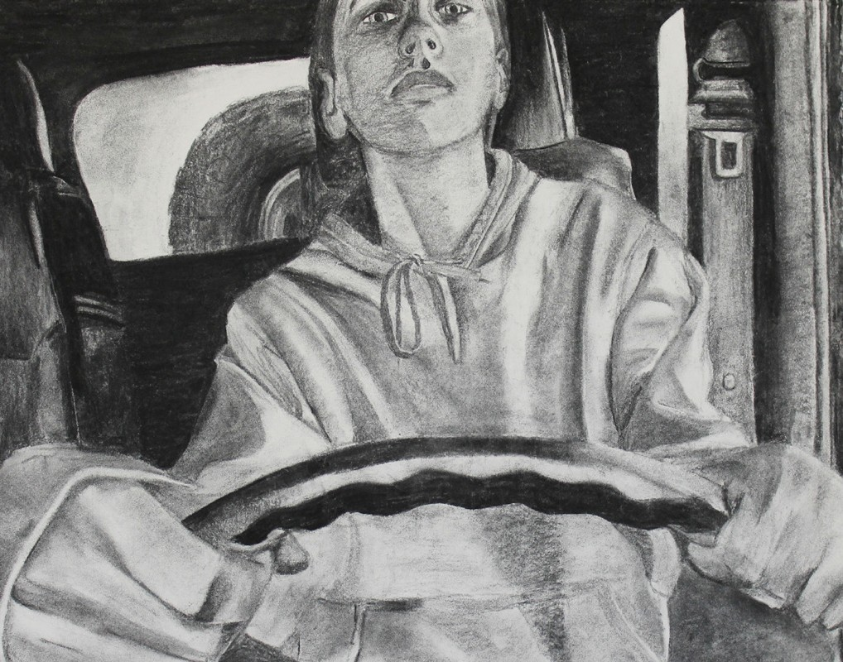What do you

bring with you to

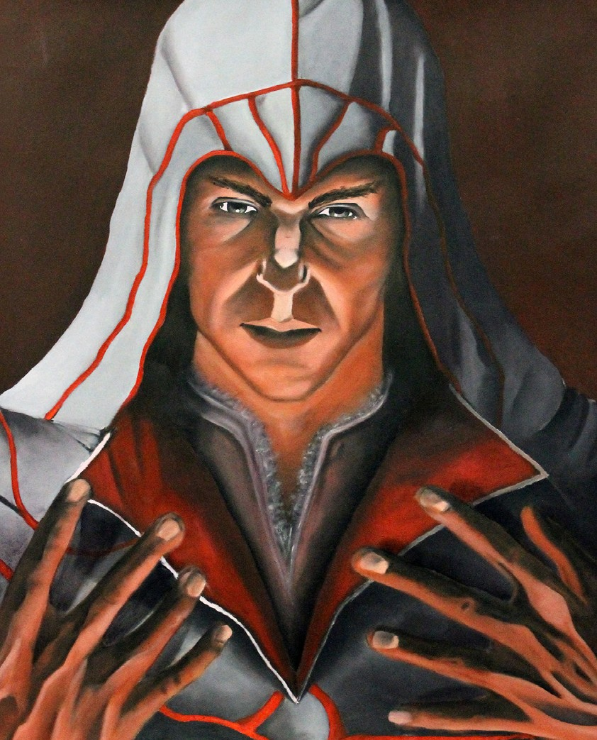AP Studio Art?? Electronic images From the Past:
□  | 1. | Funny Face Portrait
□  | 2. | Warhol Portrait
□  | 3. | B&W Glass Charcoal

Junior Year:
□All Pieces - should be approx 8 digital images
□All digital images will be on the “L” drive
AP Studio
AP14
Folder with your name - 4 sub folders
Breadth, Concentration, Extra, Source

Summer Work - Mandatory
□ 4 pieces of quality work
You pick media, subject matter and size.
Tell me who you are and what matters to you. These can be anything but it must be very good You may attend a class of some kind.
No excuses will be accepted in September.
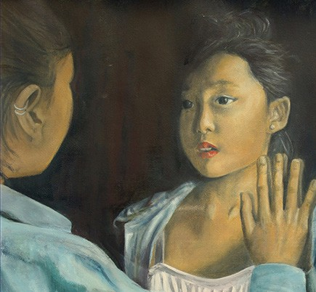□Summer work will be your first AP Studio Grade.

Future Work
You will learn:
□to photograph all of your work as you finish it
□color correct and crop
□The integrity of the artwork must stay the same.

If you wish to be eligible to propose a senior mural after
the AP Exam is completed you must have an A- year average for the AP Studio Course.
You will be making a new piece of art every two weeks.

