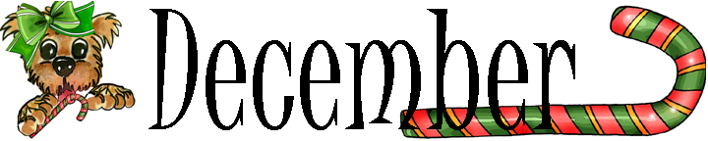
Cookies
Find and circle all of the types of cookies that are hidden in the grid.
The words may be hidden in any direction.
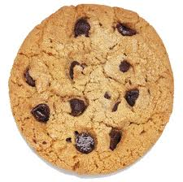
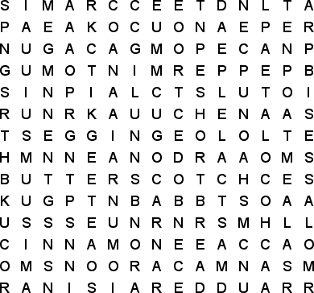
ALMOND  BRAN  BUTTERSCOTCH  CHOCOLATE  CINNAMON  COCONUT |  | GINGERBREAD  MACAROONS  MERINGUE  MOLASSES  OATMEAL  PEANUT |  | PECAN  PEPPERMINT  PUMPKIN  RAISIN  SHORTBREAD  SUGAR

Did you enjoy this puzzle? Visit: http://www.puzzles.ca/wordsearch.html

Visit the Food Services webpage at Fairfieldschools.org

