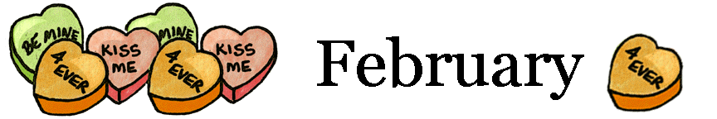

Did you Know????  Did you know there are FIVE daily meal choices for lunch at the elementary schools?? Students have the option of choosing a chef salad lunch, a cereal and yogurt lunch, a bagel and yogurt lunch, a sandwich or the “hot” lunch. All of these selections come with fresh fruit and veggies and low-fat milk.  Encourage your child to try one of these meals!! | Lunch Accounts  Register on MyPaymentsPlus (formerly Mealpayplus) and use features on their website at no charge. All you need is your child’s student identification number. Call the food services department at 203-255-8370 if you need your child’s student identification number.  On the website, you can receive low balance e-mail notifications when your child’s lunch account balance gets below a certain level. You can also view what your child ate for lunch. You can use these features without making payments through the website.  www.MyPaymentsPlus.com

Valentine's Day Fun Fact
Here is the most enjoyable and unbelievable collection of Valentine's Day Fun Facts. Share these fun facts with your friends to amaze them this Valentine Day.
- About 1 billion Valentine's Day cards are exchanged in US each year. That's the largest seasonal card-sending occasion of the year, next to Christmas.
- Women purchase 85% of all valentines.
- In order of popularity, Valentine's Day cards are given to teachers, children, mothers, wives, sweethearts and pets.
- Parents receive 1 out of every 5 valentines.
- About 3% of pet owners will give Valentine's Day gifts to their pets.
- Valentine's Day and Mother's Day are the biggest holidays for giving flowers.
- Worldwide, over 50 million roses are given for Valentine's Day each year.
- California produces 60 percent of American roses, but the vast number sold on Valentine's Day in the United States are imported, mostly from South America. Approximately 110 million roses, the majority red, will be sold and delivered within a three-day time period.
- 73% of people who buy flowers for Valentine's Day are men, while only 27 percent are women.
- Men buy most of the millions of boxes of candy and bouquets of flowers given on Valentine's Day.
- In the Middle Ages, young men and women drew names from a bowl to see who their valentines would be. They would wear these names on their sleeves for one week. To wear your heart on your sleeve now means that it is easy for other people to know how you are feeling.
- The Italian city of Verona, where Shakespeare's lovers Romeo and Juliet lived, receives about 1,000 letters addressed to Juliet every Valentine's Day.
- Richard Cadbury invented the first Valentine’s Day candy box in the late 1800s.
- Alexander Graham Bell applied for his patent on the telephone, an "Improvement in Telegraphy", on Valentine's Day, 1876.
Visit the Food Services webpage at
www.fairfieldschools.org

