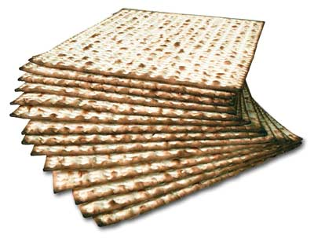
Matzo crackers will be available on the lunch lines on Tuesday, April 19th; Monday, April 25th; and Tuesday, April 26th.

